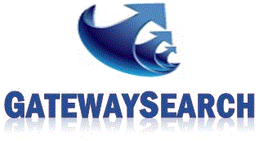 | Candidate Referral Form

Referral Guidelines
- To refer a candidate, please complete this entry form and return it, along with a copy of the candidate’s resume (optional) to future@gatewaysearch.com.
- All information regarding the submittal of candidate resume and/or referral will remain strictly confidential. Gateway Search will never disclose to a candidate the origin of where we obtained their information.
- Submittals must be received February 7, 2018 through May 15, 2018.
- Winner will have the choice of: 60 inch Samsung 4K Ultra HD TV ($700 value to be presented as a Best Buy or Amazon gift card) OR One (1) Overnight Stay at the Borgata, Atlantic City plus a $200 dinner/entertainment allowance. ($700 value to be presented as a Borgata or Visa gift card)
- Drawing will be held May 16, 2018 at 12:00PM EST. Gateway will call or email the winner directly. The winner will also be announced on social media (Facebook, Twitter & LinkedIn) as first name and initial of last name. Example: Thomas K. Winner has 2 weeks to claim his/her prize.
- More chances to win: After a candidate’s information has been received, it will also be entered into our candidate database. If a candidate you refer is submitted on behalf of Gateway Search and hired by our client within one (1) year of the candidate referral submittal date, you will receive a referral award of $200 after the new employee has worked for the Gateway Search client for 90 days.
- - - - - - - - - - - - - - - - - - - - - - - - - - - - - - - - - - - - - - - - - - - - - - - - - - - - - - - - - - - - - - - - - - - - - - - - - - - - - - - - - - - - - - - -

Your Info
Name: |  | Name | Date: | Date
Email: |  | Email
Telephone: | Telephone

Referral Information
Candidate Name: |  | Candidate Name
Email: |  | Email
Telephone: | Telephone
Current Position/Employer: | Position

Cut & Paste Résumé (optional):

Please return to: future@gatewaysearch.com by May 15, 2018

